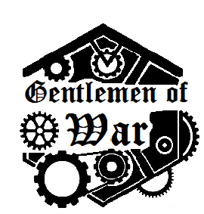

The Rulebook (For the demo)
A game by Everest Guo

https://www.gentlemenofwar.com
Introduction
In this game, you are a commander of a single warrior, each with their own traits and stories, and can be equipped with all sorts of weaponry, from makeshift pistols that sprays high-pressure steam to hybrids between a pike and a cannon. A deck of orders will used to command your gentleman (or lady!) in a battle. Turns happen simultaneously to mimic the unpredictability and the quickness of war, so care must be taken to plan and coordinate attacks, and to predict what the enemy will do.

Basic Rules
Elements of the game:
Orders:
Orders are the cards you play and draw each turn to control your character. In this demo game, there are 4 types, each with 4 copies, adding to 16 in each deck.
[Advance] moves you 1 tile in any direction.
[Press On] moves you 2 tiles in a cardinal direction. (front, back, left, or right)
[Draw Arms] uses your ranged attack, dealing 100% of the base damage on a direct hit, and base damage times glancing damage on a glancing hit (if the target moves, or if they are in your glancing range). May be able to play intercardinally, if the weapon allows it (represented by arrows in lower corners).
[Strike!] is identical to [Draw Arms], except it uses the melee attack.
[Crawl] is what all your orders become after you are downed. More on that later.
For each order, you may aim it in many ways to declare the direction in which the order is executed. Some weapons can be aimed intercardinally, and some can’t, as indicated by the symbol on the lower right. Check the weapon and character catalogue for more details.
The four decks each adhere to a faction’s theme. Orders of the same deck should be kept together, but do not need to correspond to your character’s faction. The differences are only cosmetic, and exist to make card sorting easier.

Characters and weapons:
A character consists of three vital parts: the melee weapon, the ranged weapon, and the character itself. Characters and weapons can be mixed and matched freely to better suit your playstyle and role. Each time a melee attack is executed in combat, follow the directions on the melee weapon, and the same for ranged weapons. Note that some weapons are a combination of both ranged and melee (dual-wielded weapons), and includes both a melee and a ranged attack. If you choose it, you may only use this one weapon in the entire game.
To reduce picking time and information, players may draw randomly. The demo cards are chosen so that every combination is balanced, and no specific combination is too much better than others.

Some of the characters and weapons included have been changed by the community in investigation storylines! To learn how you can participate and influence the game, go to the website on the cover, or to https://www.reddit.com/r/GentlemenofWar/, our official subreddit, or https://discord.gg/NfjSxTsC4y, our discord server! Anyway, moving swiftly on…

Anatomy of a card:
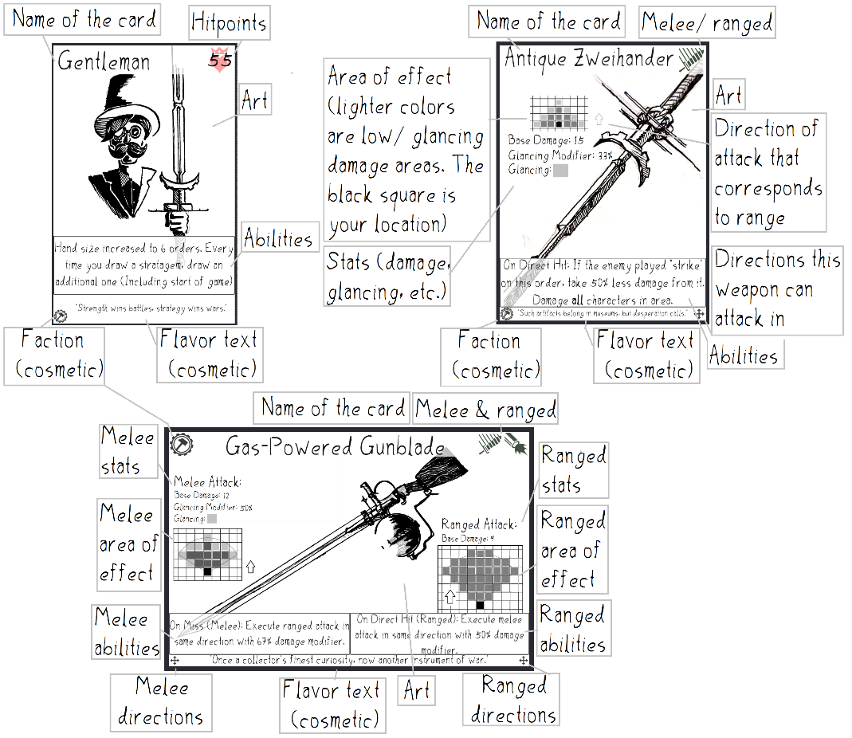

Pieces and hit points:
Each player needs a piece that represents their character. This piece is what moves and executes attacks. To keep track of hit points, players can write down numbers or they could also each get two 10-sided dice. One goes from 0-9 and one from 00-90. These will be used to keep track of hit points, with the sum being the total amount remaining. (This is why the highest hit point character has 99 hit points: 9 + 90 is the highest number that can be shown on the dice).

Phase one of combat: Commanding
During this phase, orders are put down in an order from 1 to 5 behind a screen so that the enemy cannot see. These orders will be carried out by your character in the Execution Phase of combat. You may play as many orders as you want, but you will always draw 2 cards every turn, so you can either play 2 every turn to keep a steady hand size, or play more for a better combined effect at the cost of limiting choices in the future. Some orders would have to be aimed as well, for example, [Advance] would be played so the top of the card points towards the direction you want your character to move, and an attack card like [Draw Arms] would be aimed in the direction you wish to fire, and the way you would point it depends on the firing angle of the weapon. Orders are aimed in cardinal or intercardinal directions and never between angles.
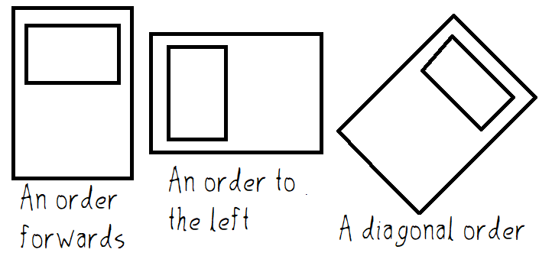
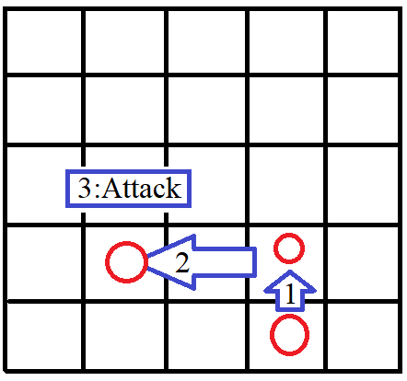
Phase two of combat: Execution
During this phase, the orders you gave to your character will be executed by them in the order you gave them, for example, you play [Advance] forwards, [Press On] leftwards, then [Draw Arms] forwards. The actions on the right would happen in the displayed order.
If two or more characters attempt to move to the same tile, none of them will move and their orders do nothing.

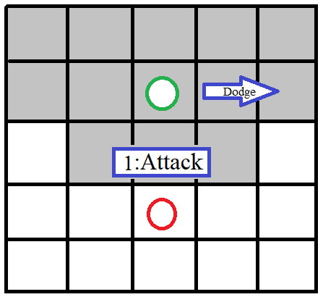
If an enemy moves on the same order as you attack, they will dodge it, even if they are still within range, as shown to the right.
If you attacked with melee (Or if the weapon says that it “glances on dodge”), you will deal reduced damage equal to base damage times the glancing modifier. For example: Green moves in the same order Red fires his Standard-Issue Clipgun. It is dodged, but the clipgun deals glancing damage with a 60% modifier. 60% * 10 = 6 damage to Green. If Red was playing as the Solak Sharpshot, they would have a 50% bonus to glancing damage. (50% + 60%) * 10 = 11 damage to green.
If a character dies in the middle of a turn, all their orders after the order in which they died will be discarded.
If on later orders, not all players played anything, those who did not play will stay still while those who did play their orders will have them resolve in the same way as before.
After all orders are resolved, enter phase three of combat.

Phase three of combat: Redraw
Put all executed orders into the discard pile while drawing 2 from the deck. If the deck is exhausted, reshuffle the discard piles and put it face down as the new draw pile.
Repeat these three phases until either a win condition is satisfied, or until all characters on one team are downed or dead.

(Optional) Downing and Killing:
Once a character is reduced to 0 hit points or lower, they are downed. Their deck is completely reshuffled, 2 orders are drawn, and 2 more are drawn every turn starting next turn until the deck runs out. While downed, every order is a [Crawl] order, which moves the character 1 in any cardinal direction. Each time a downed character takes damage, they discard an order from their draw deck. All damage discards the same amount, including glancing. A downed character can dodge hits with [Crawl]. One turn after the deck is exhausted, the character dies for good.
Whilst downed, if a teammate ends a turn directly adjacent to a downed character, they are revived at the beginning of the turn. After they are revived, they will die when they are knocked out again. Characters are revived with 25% of their maximum health.
If all characters in a team are downed, they will lose.

Q & A:
This section is for some commonly asked questions regarding confusing points in the game. Some important points will also be brought up.
Q: What if two characters cross paths?
A: It depends. If they try to move to the same tile, or if a character moves into an occupied tile, neither moves. If they cross paths, but do not move to the same tile, they can move (Even if they move against each other). You can modify the rule so that the character with more maximum hit points moves and nudges others, since all characters in the base game have different hit point values.
Q: Can I leave orders blank?
A: No. That makes the game far too unpredictable.
Q: I have the demo now! I don’t need to buy the final product! Aha!
A: I guess so. This demo only has 1/3rd of the characters and weapons of the final game. It also does not have a map with objectives, nor does it have a key part of the game: Stratagems. You will also miss out on a detailed guide for every single character and weapon in the game, and player mats plus screens. If you don’t mind losing out on those things, then sure, you don’t need the final product.
Q: Do I need to play with characters and weapons from the same faction?
A: No. Everything related to factions is cosmetic.
Q: What type of order is [Crawl]?
A: It is a movement order, which means Slyfoot Scout can play them intercardinally (Turning them into [Advance]).
Q: How are modifiers stacked?
A: Additively. A 50% decrease and a 25% increase nets a total of 25% decrease, or 50% + 25% = 75% of the original instead of 62.5%.

Other Points & Confusion:
Maximum hand size: 5. Draw 2 at the start of each turn. On turn 1, draw to maximum. If your hand is full while drawing, discard orders until you can hold all of them. Played but not executed orders on the mat count as being in hand.
There are 4 orders of each type, with 4 types in each deck.
In case of a draw, the team whose remaining character took more overkill damage that order loses. If it is the same (which is very unlikely), consider it a draw, or continue orders until a character takes damage. This should realistically happen less than 1% of the games, so if it does, maybe everybody wins.
All damage taken in an order or at the end or beginning of any phase is taken at the exact same time.
Glancing damage happens as long as a character was in range during that order. If you dodge out of range, you take glancing damage, if you move into range, you also take glancing damage. If you move through range ([Press On] through a one-tile range) you would not take any damage, since technically, [Press On] moves you from your beginning tile directly to the end tile. It moves characters through other characters, too.
Final Notes:
Thank you for playing Gentlemen of War (and reading until the end). It has always been my dream to develop a game by myself, and all of you contributed to what I have. Thank you to all the people who helped me on the development process!
Note: The icons used in some of the cards: four arrows pointing outwards, eight arrows pointing outwards, abstract pattern, etc. are all taken from Card Creator. All other artwork is done by me by hand. The font is created by me, though the Old English Text font is used on the back of order cards.

